**Instructions for tool changer bioprinter**

To use the bioprinter, either running prints or writing macros for automation, it is necessary to understand the way that the bioprinter interpret instructions. The printer uses 4 stepper motors to control the axes of the bioprinter. 3 motors for XYZ and 1 motor for the tool changing mechanism. All movements and behaviors of the bioprinter is controlled by g-code. G-code can be entered manually, one string at a time, or by running a file containing several strings of g-code, which will be run sequentially. The files generated from a slicer is just a text document containing a sequence of g-code commands, controlling movements of all axes in the system. Below are some examples of how G-code is interpreted by the controller card. Text written after a “;” is ignored by the machine, and is present only for describing the action of the command.

*Example 1:*

*G1 X100 F5000*

This command will move the toolhead to the coordinate X100 with a speed of 5000 mm/min. No other axes will be moved since no other axes than X is specified.

*Example 2:*

*G1 X100 Y100 F5000*

This command will move the toolhead to coordinate X100 Y100 in a coordinated movement with a speed of 5000 mm/min.

*Example 3:*

*G1 X100 F5000*

*G1 Y100 F5000*

This set of commands will first move the toolhead to coordinate X100, followed by movement to Y-axis to coordinate Y100. These moves will be done after each other, and not in a coordinated manner as in example 2. Each movement will be done with a speed of 5000 mm/min.

At any point when the machine makes a movement, there is a g-code command being sent to the controller. No movement will be done randomly, so unexpected movements of the bioprinter is always caused by instructions given to the printer. This is good to keep in mind when troubleshooting erratic behavior. If it is doing something you don’t understand why, ask yourself the following:

* What sequence of commands can make the printer behave like this?
* Where could these commands be?
* What triggers these commands to be sent?

**Starting up the bioprinter**

1. Start the bioprinter on the switch (left backside)
2. Connect to the WiFi-hotspot created by the controller card.
   1. SSID: TC Bioprinter B3
   2. PW: 3D-prin7ing
3. Browse to 192.168.111.111 to reach the Duet Web Control. This is the interface you will use to control the bioprinter. Learn more about the interface here: https://docs.duet3d.com/User_manual/Reference/Duet_Web_Control_Manual

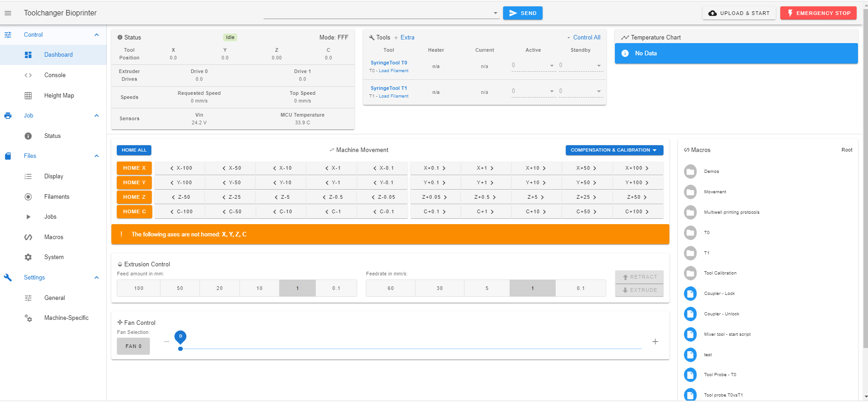

The motors used on this printer is “open loop”, meaning that motors do not provide information about the position in absolute terms. All movements are done in relation to a “home position”. All axes have a minimum position and a maximum position, and the “home position” is defined as the minimum position. This means that front left is the home position for the XY axes.

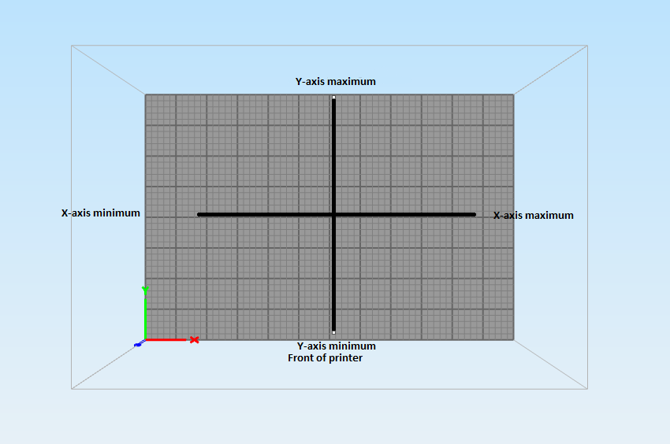

First step of using the bioprinter is making sure that the home position is correctly identified. This is done by running a g-code command for homing the axes.

The command for homing an axis is G28. Since we need all axes to find their homing position, their reference point, we need to home all axes. This can be done by manually sending the command G28 XYZC, or pressing the “Home all” button in DWC. The only thing this button does in sending that command to the g-code interpreter on the controlled card.

When your axes are homed, the buttons in DWC will turn blue, indicating that the axis limits are now known, and the printers coordinate system is established.

With the printer homed, lets explore what happens if we want to pick up a tool mounted in its tool dock. The tools are numbered from 0 to 3. The outer left tool is T0, the one right next to it is T1 etc. All text written after “;” is just comments to understand the command, and will not be interpreted by the controller card as instructions. The command for picking up a tool is:

T0 ; This command tells the printer to pick up T0. When this command is sent, it is triggering a macro containing a list of g-codes that involves all the movements of picking up the tool.

When a T-command is sent, lets say T0 in this example, the following happens.

1. A macro called t0pre is run. This macro contains the instructions for picking up T0. By modifying this macro, we can control the behavior from the point where the Tx command is sent until the tool is picked up.
2. Another macro called t0post is run. This macro is started when the tool is picked up and the g-code in t0pre is finished. By modifying this macro, we can control the behavior from the point where the tool is picked up. This could include priming of nozzles, wiping of excess bioink from the needle or positioning the toolhead appropriately.

The macro for leaving the tool in its dock is “T-1”. This will leave the selected tool in its dock.

When T-1 is sent, it calls a macro called t0free. This contains the instructions for leaving the tool in its dock.

All these macros can be found under the “system” tab in DWC. Take some time to look into these files to understand what is actually happening when the tool change commands are sent to the printer. There are a huge variety of g-code commands available, see website for more commands and parameters: https://docs.duet3d.com/